**UT Test Cases**

1. **IP Validation**
2. **Sunny Test Case**



1. **Rainy test cases (IP containing alphabets, special characters, out of range and not containing 3 “.”)**

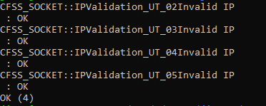

1. **Port Number Validation**
2. **Sunny Test Case**



1. **Rainy Test Cases (Port number Out of range, containing alphabets)**

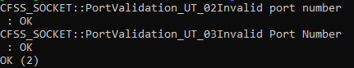

1. **Phone Number**
2. **Sunny test case**



1. **Rainy test cases (Not 10 digits, containing alphabets, special charecters)**

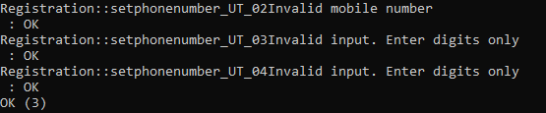

1. **Type of Call Forwarding**
2. **Sunny Test Cases (Valid entries 1, 2 and 3)**

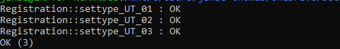

1. **Rainy Test Case (Digit other than 1,2 or 3)**



1. **Call forwarding Service**
2. **Sunny Test Cases (Valid entries 0 and 1)**



1. **Rainy Test Case (Digit other than 0 or 1)**



1. **Call Status of the Client**
2. **Sunny Test Cases (Valid entries 1,2 and 3)**

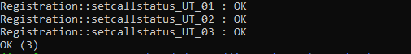

1. **Rainy Test Case ( Digit other than 1, 2 or 3)**



1. **Destination phone number**
2. **Sunny Test Case**



1. **Rainy test cases ( not 10 digits, containing alphabets, special characters)**

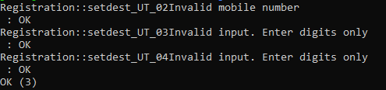

1. **Password**
2. **Sunny Test Case**



1. **Rainy Test Cases (less than 7 characters, containing only small letters, containing only capital letters, containing only numerical, not containing small letters, not containing Capitals, not containing numerical)**

